Customer Support Ticket Priority Prediction

Project Title
Customer Support Ticket Priority Prediction and Automated Assignment System Using Agentforce

Problem Statement
Customer support teams receive a large number of tickets daily, but prioritization and assignment are often manual. This leads to delays in resolving critical issues and poor customer satisfaction.
There is a need for a system that:
- Automatically classifies ticket priority
- Assigns tickets to the right support agent
- Reduces response time
- Uses AI to understand urgency
User Stories
- As a Support Agent, I want tickets to be automatically prioritized so that I can focus on critical issues first.
- As a Customer, I want urgent issues to be resolved quickly so that my experience improves.
- As a Manager, I want tickets to be assigned automatically to the right team so that workload is balanced.
- As an AI Agent (Agentforce), I want to analyze ticket details and trigger automation so that manual work is reduced.

Expected Outcome
- Faster ticket resolution
- Improved customer satisfaction
- Reduced manual effort
- Intelligent ticket handling
- Better team productivity

Custom Object

Object Name:
Support Ticket Intelligence

API Name:
Support_Ticket_Intelligence__c

Fields
Field Label | API Name | Data Type | Description
Ticket Number | Ticket_Number__c | Auto Number | TKT-{0000}
Customer | Customer__c | Lookup (Account) | Related Account
Contact | Contact__c | Lookup (Contact) | Customer contact
Issue Type | Issue_Type__c | Picklist | Technical, Billing, General
Description | Description__c | Long Text Area | Issue details
Priority Level | Priority_Level__c | Picklist | Low, Medium, High
Status | Status__c | Picklist | New, In Progress, Resolved
Created Date | Created_Date__c | Date | Ticket date
Assigned To | Assigned_To__c | Lookup (User) | Support agent
SLA Breach Risk | SLA_Breach_Risk__c | Checkbox | Risk flag
Resolution Time (hrs) | Resolution_Time__c | Number | Time taken

Auto-Launched Flow Logic (Modified for this Project)

1. Flow Type
Auto-Launched Flow (No Trigger or called from Agentforce)

2. Variables

Input Variable
Label | API Name | Type | Input
Account Name | varAccountName | Text | Yes

Output Variables
Label | API Name | Type | Output
Account Id | varAccountId | Text | Yes
Ticket Id | varTicketId | Text | Yes
Priority Level | varPriorityLevel | Text | Yes
Assigned Agent | varAssignedTo | Text | Yes
Action Message | varActionMessage | Text | Yes

3. Step-by-Step Flow Implementation
Step 1: Get Account
Element: Get Records
- Label: Get Account
- Object: Account
- Condition:
  - Name Equals {!varAccountName}
- Sort: CreatedDate DESC
- Store: Only first record
Step 2: Assignment (Store Account Id)
Element: Assignment
- Label: Store Account Id
Set:
- varAccountId = {!Get_Account.Id}
Step 3: Get Ticket Record
Element: Get Records
- Label: Get Ticket
- Object: Support_Ticket_Intelligence__c
- Condition:
  - Customer__c Equals {!varAccountId}
- Sort: CreatedDate DESC
- Store: Only first record
Step 4: Assignment (Store Ticket Id)
Element: Assignment
- Label: Store Ticket Id
Set:
- varTicketId = {!Get_Ticket.Id}

Step 5: Decision (Analyze Description)
Element: Decision
- Label: Analyze Description

Outcomes:
High Priority
- Description contains:
  - "urgent"
  - "not working"
  - "failure"
(Use multiple conditions with CONTAINS)
Medium Priority
- Description contains:
  - "issue"
  - "slow"
  - "delay"
Default Outcome
- Low Priority

Step 6: Assignment (Set Priority Level)
High Path
- varPriorityLevel = "High"
Medium Path
- varPriorityLevel = "Medium"
Low Path
- varPriorityLevel = "Low"

Step 7: Decision (High Priority Check)
Element: Decision
- Label: Is High Priority
Condition:
- varPriorityLevel Equals "High"

Step 8: Create Task (Only High Priority)
Element: Create Records
- Object: Task
Set Fields:
- Subject = "Urgent Ticket Handling"
- WhatId = {!varTicketId}
- Priority = High
- Status = Not Started

Step 9: Assignment (Assign Agent Name)
Element: Assignment
- Label: Set Assigned Agent
Set:
- varAssignedTo = "Senior Support Agent"

Step 10: Optional SLA Check
Decision: SLA Risk
Condition example:
- If Created Date older than 2 days
Then:
- (Optional internal flag or message)
Step 11: Final Output Message
Element: Assignment
- Label: Set Final Message
Set varActionMessage:
- High:
"High priority ticket detected. Assigned to senior agent."
- Medium:
"Ticket marked as medium priority. Will be handled shortly."
- Low:
"Tickets are low priority and queued for processing."
Step 12 : Save Flow
Label Name : Support_Ticket_Intellegence
Active Flow

4. Final Flow Structure
Start
→ Get Account
→ Assignment (Account Id)
→ Get Ticket
→ Assignment (Ticket Id)
→ Decision (Analyze Description)
→ Assignment (Priority Level)
→ Decision (High Priority)
→ Create Task
→ Assignment (Assigned Agent)
→ Optional SLA Decision
→ Assignment (Final Message)
→ End
Flow OutPut :
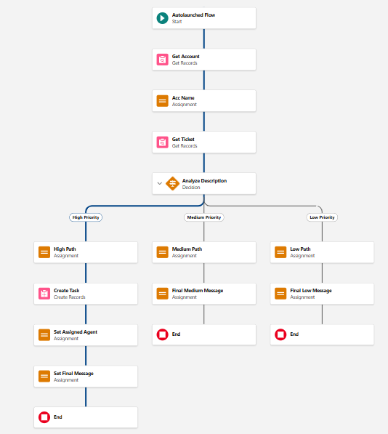
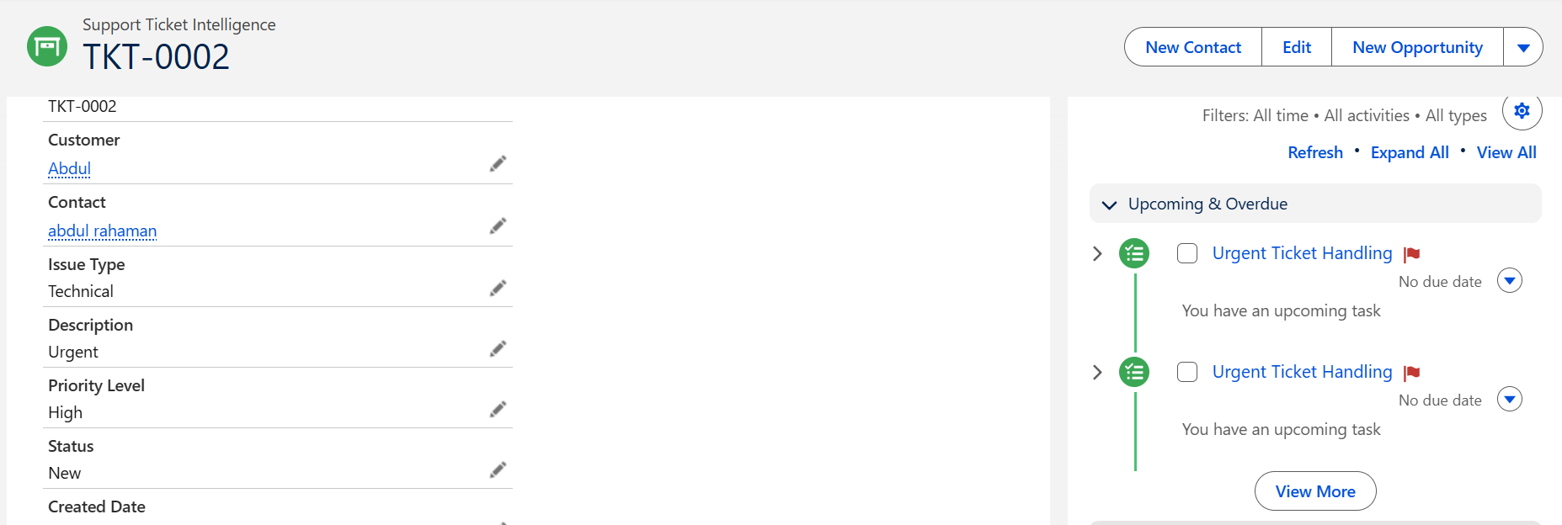

5. Final Outcome
- Takes Account Name as input
- Fetches latest support ticket
- Analyzes description using keywords
- Sets priority automatically
- Creates task for urgent cases
- Returns output to Agentforce

Agentforce Configuration
Steps :
- Go to Gear icon and Click Salesforce Go
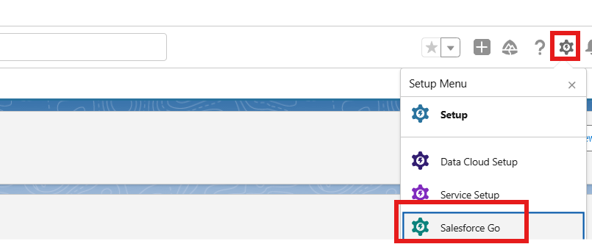
- Search Default and Select Agentforce Default then Enabled It
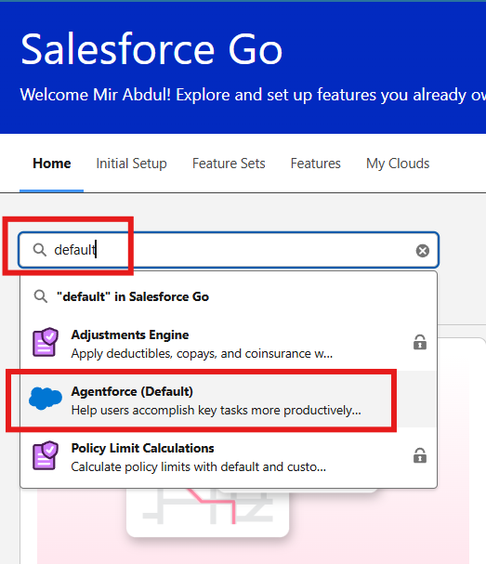
- Select Get Started ⇒ Turn On ⇒ Confirm

- Search Agents in Quick Find Box and Enabled The Agent then you will see Default Agent
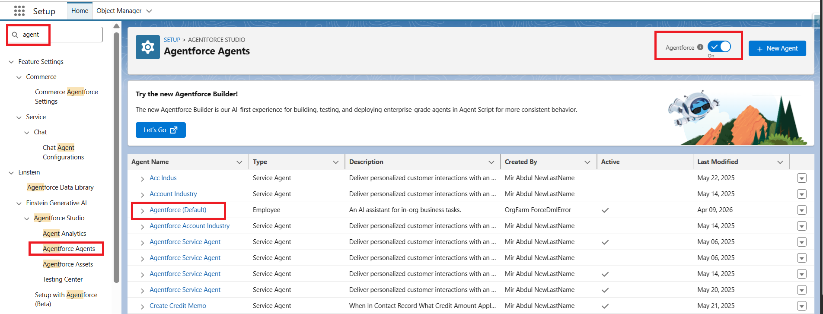
- Select Default Agent and Click Open in Builder
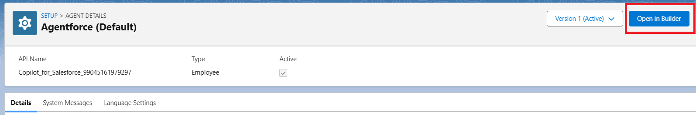

- Click New to Create New SubAgent
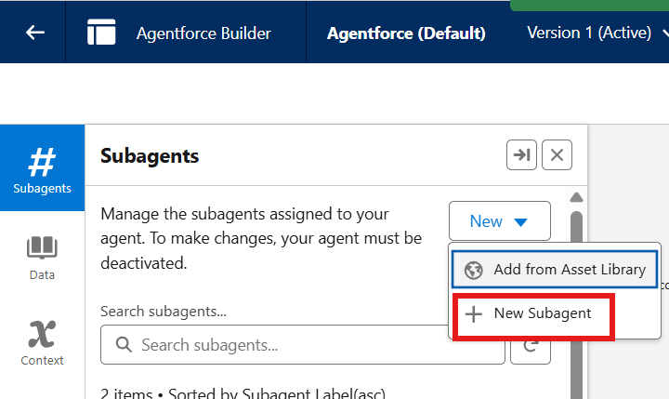

- Click Next
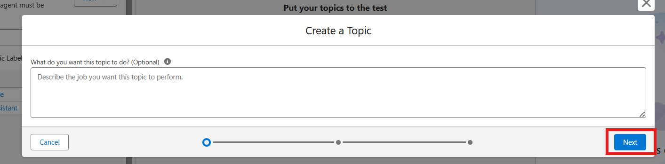

Agentforce Subagent Configuration

Name
Support Ticket Priority Analysis

API Name
Support_Ticket_Priority_Analysis

Classification Description
This topic analyzes customer support tickets to determine priority based on issue description and urgency. It handles user requests related to ticket status, issue severity, and support prioritization.

Scope
Your job is only to analyze support ticket descriptions, determine the priority level (High, Medium, Low), and trigger backend automation for task assignment. Do not handle unrelated requests such as billing, subscription management, or account updates.

Instructions
Follow these steps when this topic is triggered:
- Ask the user to provide the Account Name if not already given.
- Retrieve the latest support ticket associated with the Account.
- Read and analyze the ticket description.
- Determine priority based on keywords:
  - High Priority: contains "urgent", "not working", "failure"
  - Medium Priority: contains "issue", "slow", "delay"
  - Low Priority: if none of the above
- Set the priority level accordingly.
- If the ticket is High Priority:
  - Trigger the Auto-Launched Flow
  - Ensure a task is created for immediate handling
- Assign the ticket to the appropriate support level (e.g., senior agent for high priority).
- Return a clear response message to the user:
  - High → Inform urgent handling is initiated
  - Medium → Inform issue will be handled shortly
  - Low → Inform ticket is queued
- Do not update records directly or send emails. Use Flow for all actions.
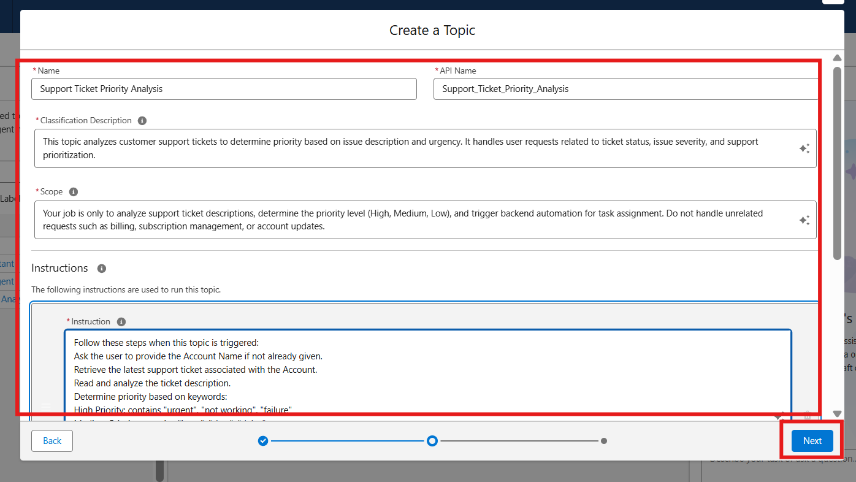

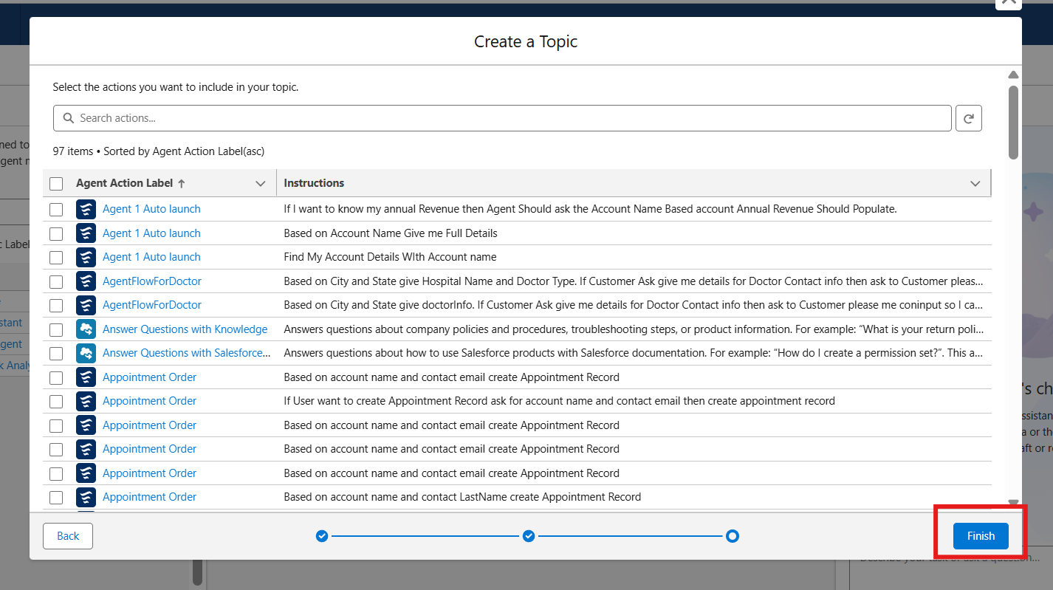
Select Topic
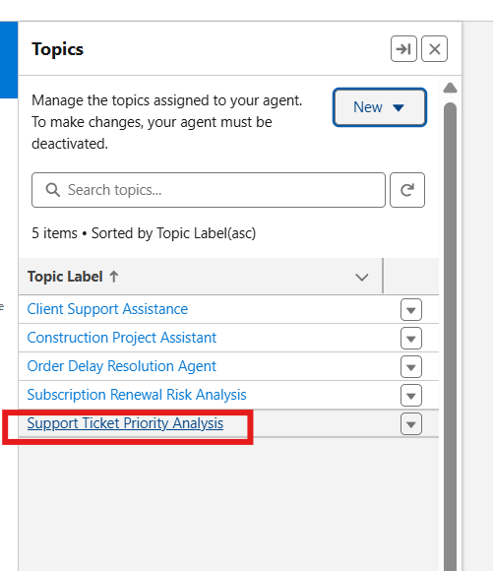

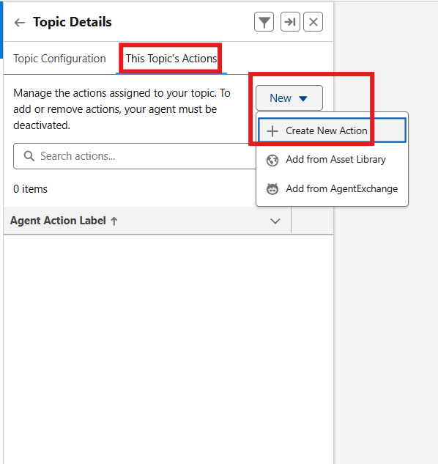

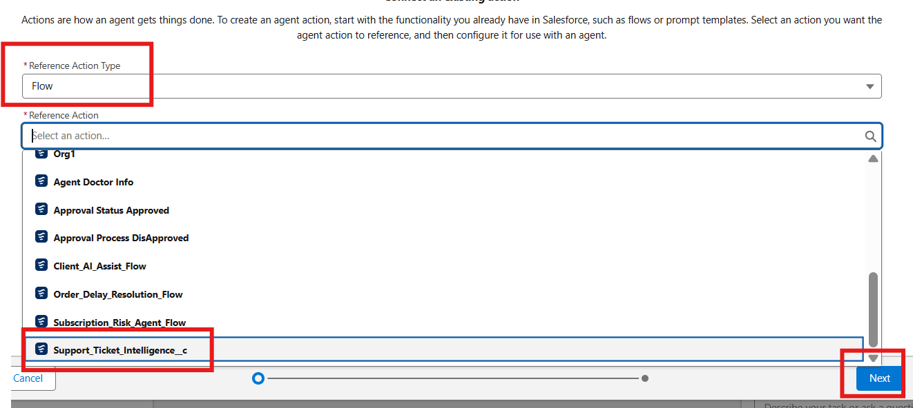

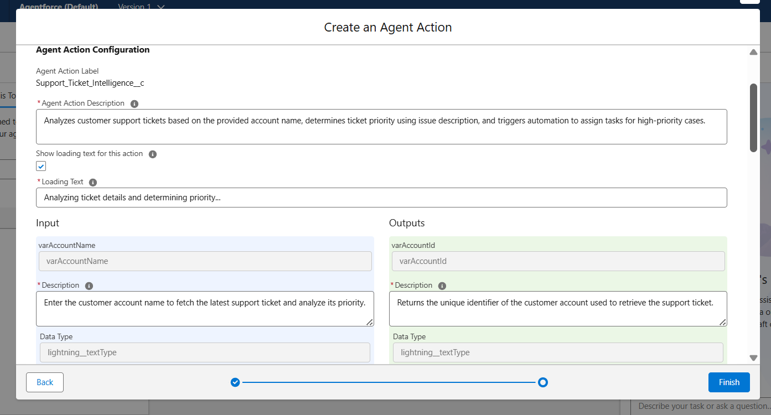

Agent Action Description
Analyzes customer support tickets based on the provided account name, determines ticket priority using issue description, and triggers automation to assign tasks for high-priority cases.
Loading Text
Analyzing ticket details and determining priority...
Input

varAccountName
- Description
Enter the customer account name to fetch the latest support ticket and analyze its priority.
- Data Type
lightning__textType
- Require Input
Enabled
- Collect Data From User
Enabled

Outputs

varAccountId
- Description
Returns the unique identifier of the customer account used to retrieve the support ticket.
- Data Type
lightning__textType
- Show in Conversation
Enabled
- Output Rendering
Text

varActionMessage
- Description
Displays the final message indicating ticket priority and actions taken by the system.
- Data Type
lightning__textType
- Show in Conversation
Enabled
- Output Rendering
Text

varAssignedTo
- Description
Indicates the support agent or team assigned to handle the ticket.
- Data Type
lightning__textType
- Show in Conversation
Enabled
- Output Rendering
Text

varPriorityLevel
- Description
Represents the calculated ticket priority level (High, Medium, Low) based on issue description.
- Data Type
lightning__textType
- Show in Conversation
Enabled
- Output Rendering
Text

varTicketId
- Description
Returns the unique identifier of the support ticket analyzed by the system.
- Data Type
lightning__textType
- Show in Conversation
Enabled
- Output Rendering
Text
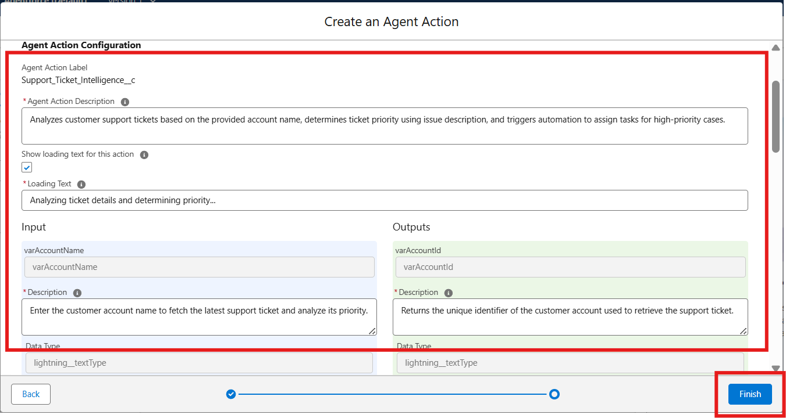

Final OutPut :
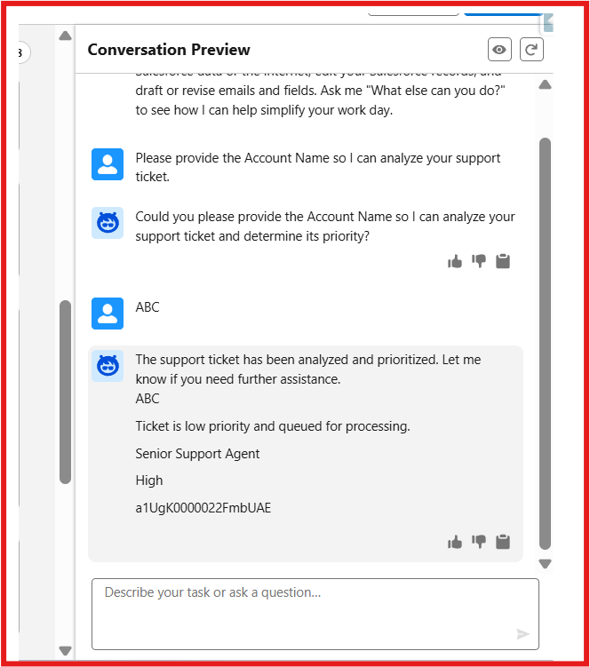
Note: If you would like to extend this scenario, you can add more variables to the flow and configure them in the agent. This will help you achieve better outputs. It’s a great way to learn. If you'd like to explore more scenarios, feel free to get in touch with me.

